Construction Worker Import Instructions (FULL IMPORT)

1. **Open Blank Adobe Fuse File**
2. **Click File>Import>Import Clothing**
3. ***Select Mesh File*** *(.obj):* Construction_Vest/ConstructionVest_012.obj
4. **Make sure the following are set:** 
   * Display Name = Construction Vest012
   * Category = Tops
   * Item Type = Clothing
   * Base Body = MaleFitA
   * Search Tags = Shirt, Vest, Top

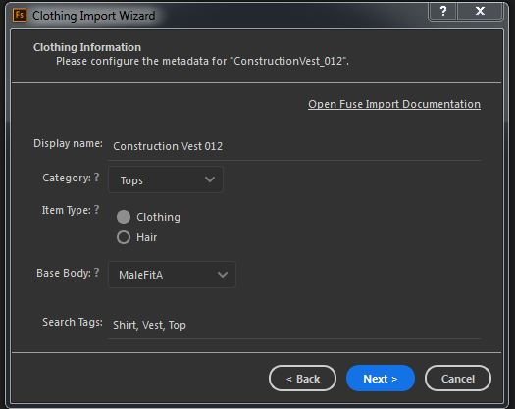

1. **Assign related textures:**
   * Color Mask = Top_MaleFitA_ConstructionVest_Mask_01
   * Normal Map = Top_MaleFitA_ConstructionVest_Normal_01
   * Detail Diffuse Map = Top_MaleFitA_ConstructionVest_Spec_01

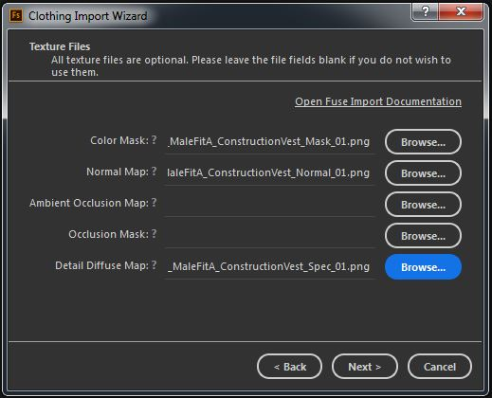

1. **Name Colored Masked:**
   * Black = *Leave Blank*
   * Blue = Shirt
   * Cyan = Shirt Inside
   * Green = Vest
   * Magenta = Buckles and Bits
   * Red = Pouches
   * White = Reflective Strip
   * Yellow = Belt and Straps

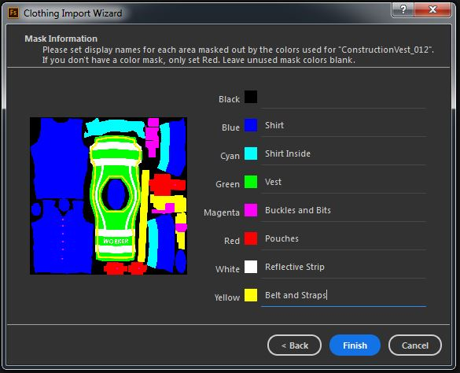

1. **Open The Construction Character**
   * File>Open: Construction_Worker_01/Construction_Worker_01.fuse
   * Can Create a Prefab of textured clothing if desired:
     1. Click on Construction Vest in the character window
     2. Then Click File>Create Prefab From Item
   * Results should look like the example picture below:

